When people are the “outside help” in this type of a process, they often regard the assets of these societies as outliers and don’t pay much attention to them. They don’t think about how the assets could help repair the problems. For instance, when I used to go on mission trips I would help rebuild or fix up houses that belonged to low income families that needed assistance. It made a difference in these peoples lives but it did nothing to change their economical position.

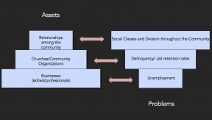

Not remembering that the assets could help fix whatever issues are in that community sounds almost silly however when you think about it in a real scenario its more understandable. For example, when I go to the math empo, I often do practice problems before the actual test. When I get one I thought it did right, wrong I will work it again but often times I don’t realize what I did wrong and I work it the same way over and over again, getting the wrong answer every time. I’m confident that the question is just wrong but I should really ask over one of the people who actually know what they are doing and not think that I am on my own for this.

