When people are the “outside help” in this type of a process, they are the “do-gooders” that see and issue and want to fix it but only do so on the surface level. They never really partake in understanding and addressing the underlying issues creating this cycle. For example, my church would always collect cans of food, especially those high in protein, to sent to struggling areas of Western Virginia to fight childhood hunger. Though no one would argue that this didn’t make a difference, it was a Band-Aid over the real issues in the area.

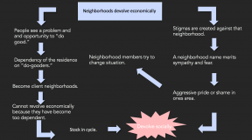

Solving an issue this way is like when two children are fighting over a toy, like my sisters and I did often. We all equally wanted it but when one of my parents came in to see what we were arguing about they would often just get rid of the toy. This solved this problem until we found a new one to fight over so they never really taught us how to solve that problem ourselves, so it continued until they did.

